Week 8 Progress Summary
- - Completed a non-disruptive backend reliability contribution by implementing GET /health in newBackend/BackendCode/app.js.
- - Verified reliability behavior through smoke testing (newBackend/tests/api.smoke.test.js), including health endpoint response checks.
- - Updated architecture documents to reflect implemented changes, including /health status in docs/HLD.md and docs/LLD.md.
- - Built and organized evidence artifacts for traceability: worklog, evidence index, snippet showcase, planner mapping, and SFIA alignment.
- - Pushed Week 8 technical and documentation updates to local Git branch for versioned tracking and team visibility.
- - Completed software architecture certification activity and linked learnings to architecture-focused technical contribution work.

SFIA Alignment (Week 8)
- Data analytics (DAAN): correlation behavior analysis and data flow interpretation.
- Information security (SCTY): reliability and validation controls via health checks and safe request handling.
- Functional testing (TEST): smoke-test suite proving endpoint stability.
- Systems integration and build (SINT): architecture mapping across frontend, backend, and analytics paths.
- Knowledge management (KNOW): evidence index, planner traceability, and structured documentation.

Reliability Evidence Infographic
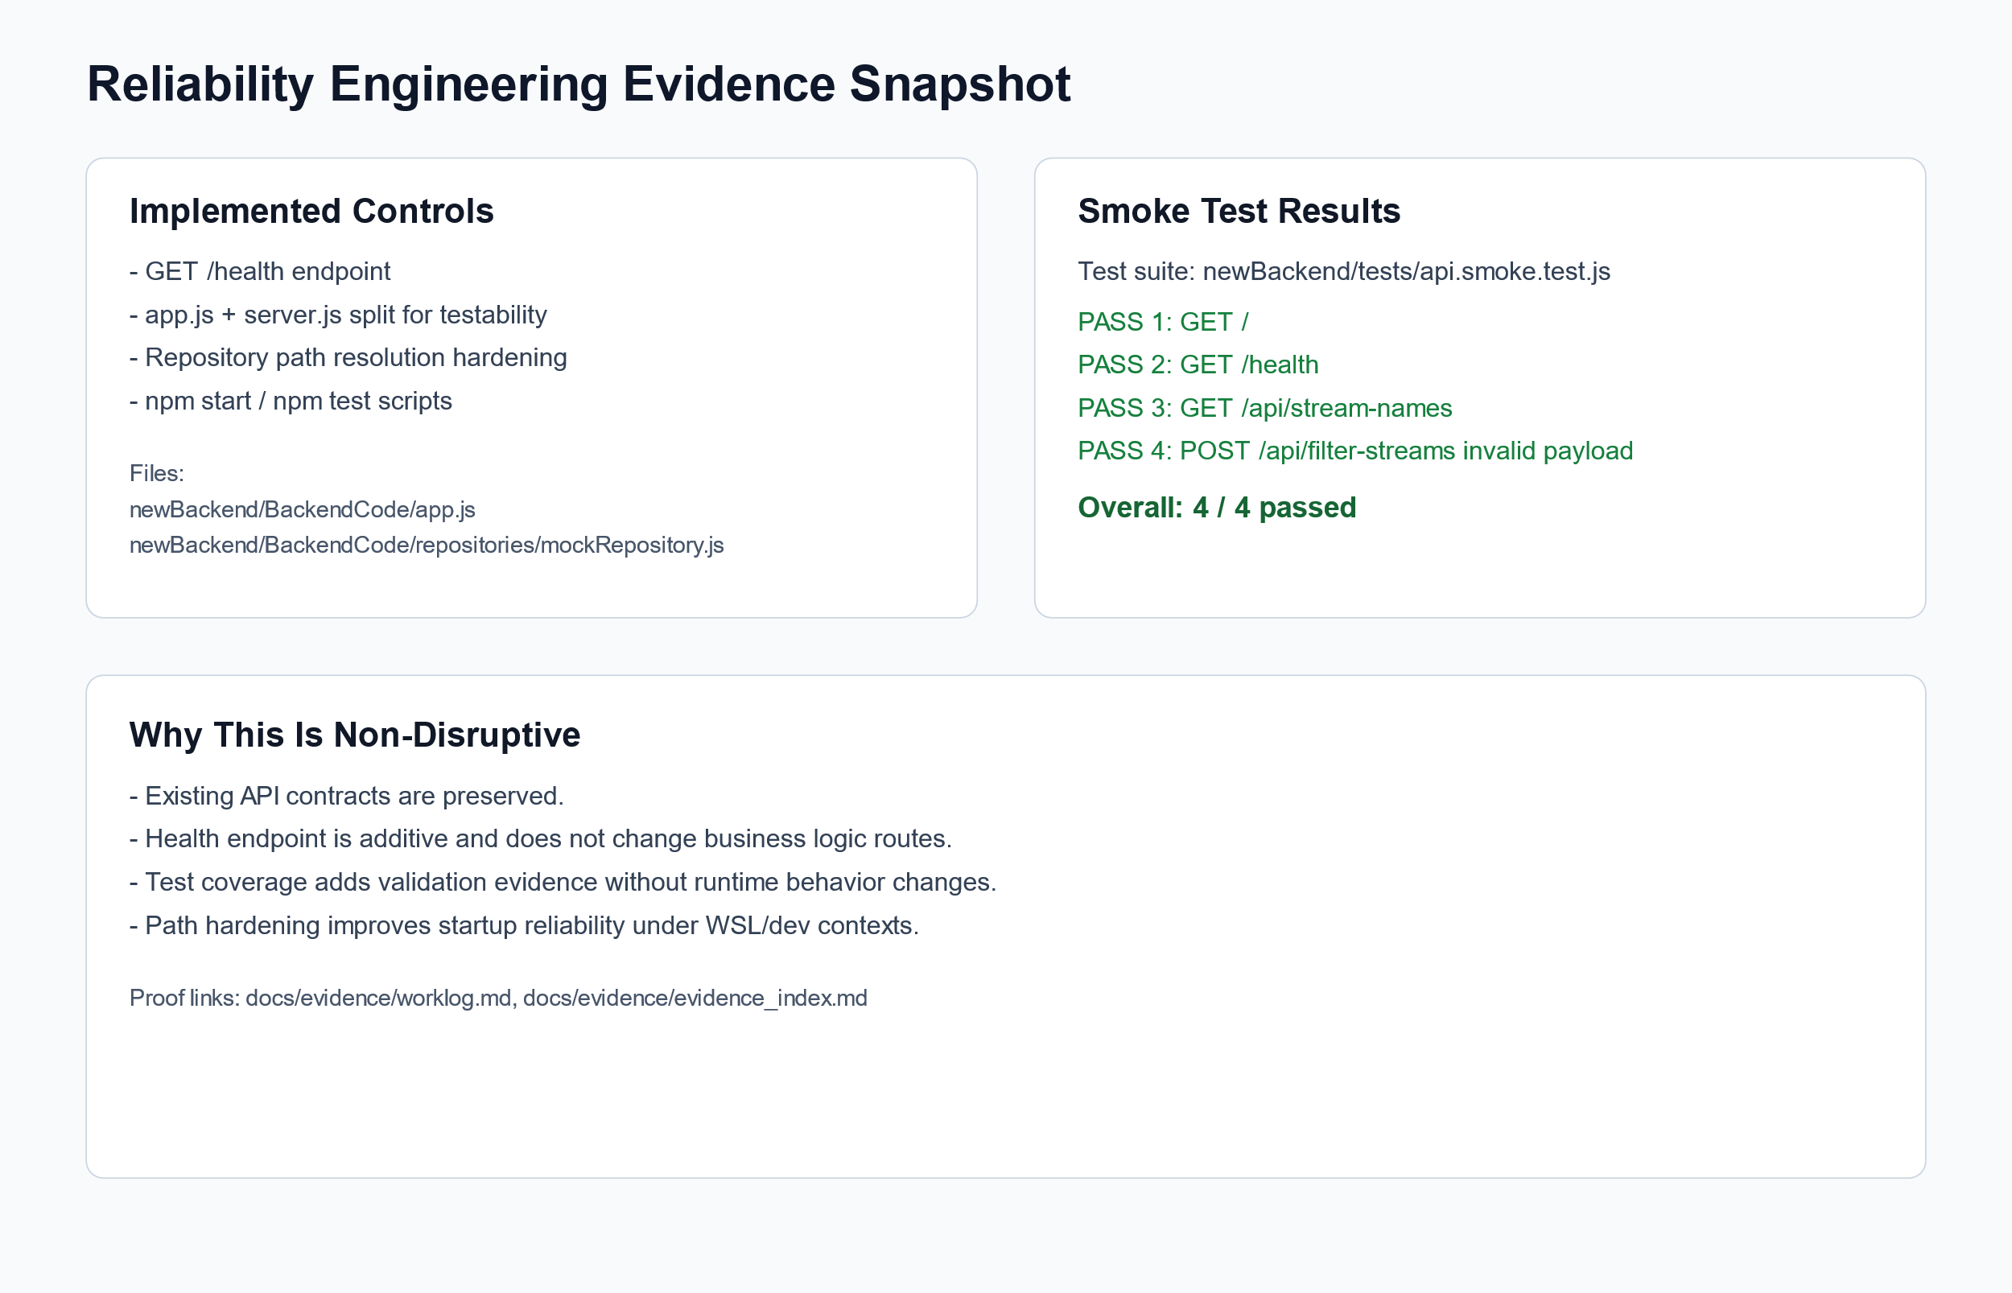
Reliability Engineering Evidence

Week 8 Technical Snippets

Technical Contribution Evidence (Code Snippets)

1) Reliability Endpoint (Non-Disruptive Additive Control)
Source: newBackend/BackendCode/app.js
app.get('/health', (req, res) => {
res.status(200).json({
status: 'ok',
timestamp: new Date().toISOString(),
uptimeSeconds: process.uptime()
});
});

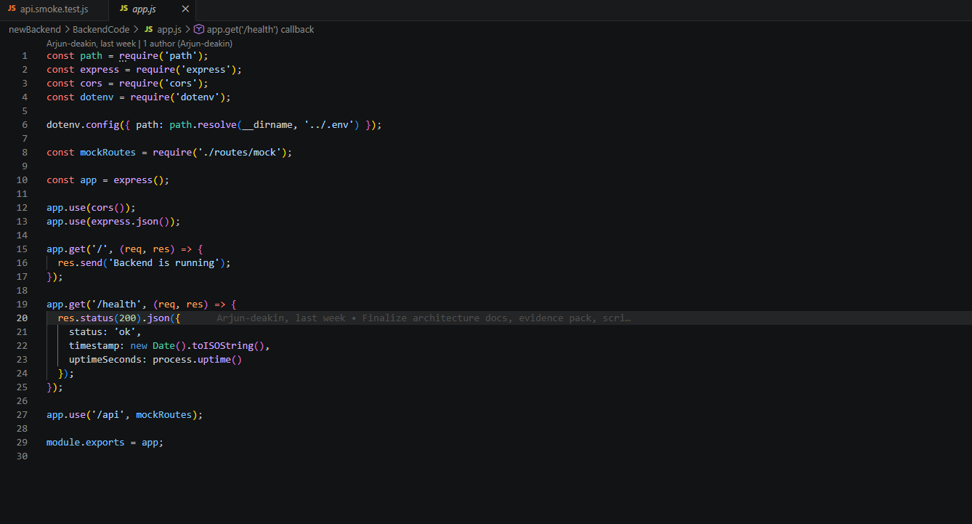

2) Automated Smoke Test Verification
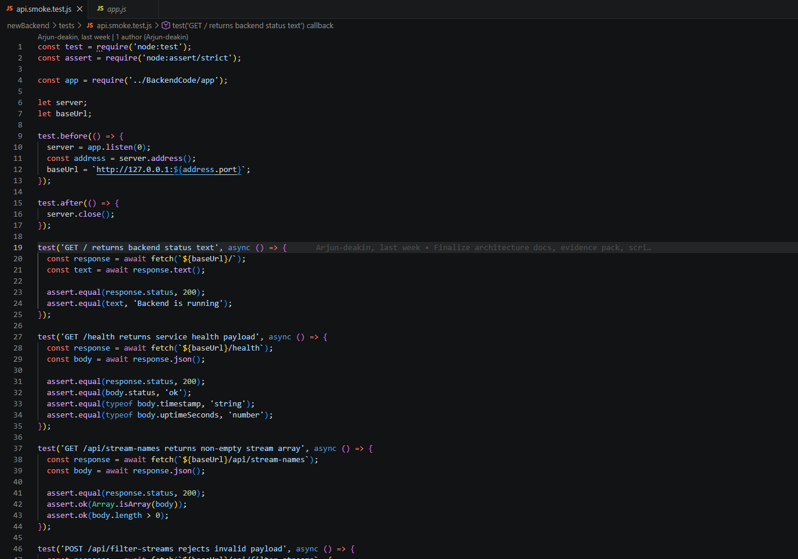

Git Evidences
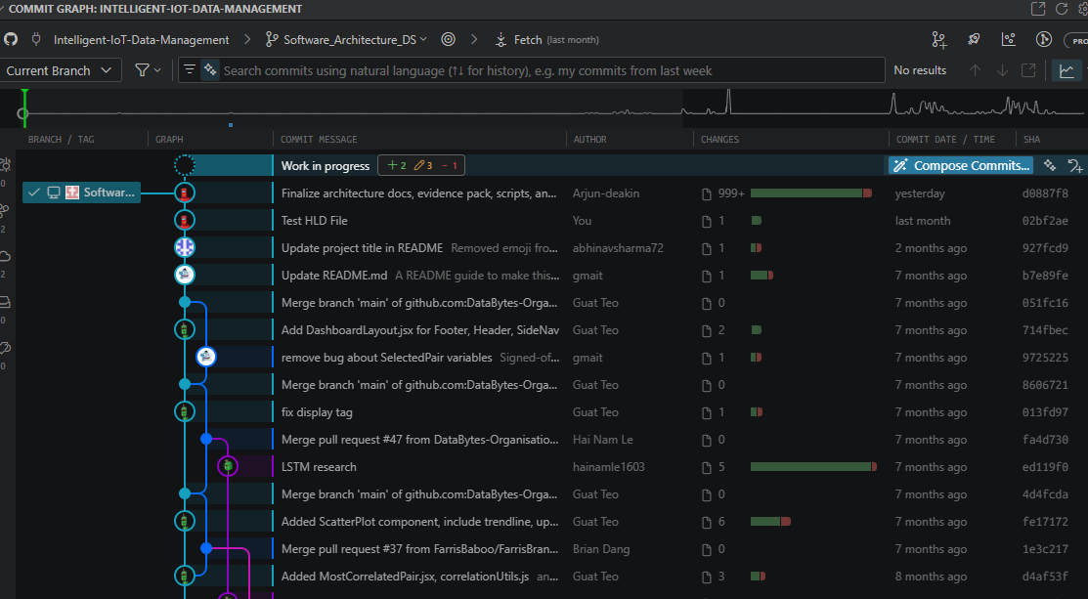

Video Evidence
Recap: Call with RACHIT GOYAL Saturday, | Meeting | Microsoft Teams
Code Walkthrough https://deakin.au.panopto.com/Panopto/Pages/Viewer.aspx?id=11af56f7-8287-4475-8278-b43f006d6395
Code Demo
https://deakin.au.panopto.com/Panopto/Pages/Viewer.aspx?id=31d7fe82-457c-4fa1-8235-b445005cc618

Planner Governance Evidence (Software Architecture Bucket)
Planner board used for architecture task planning and progress traceability:
- https://planner.cloud.microsoft/webui/plan/Zx8AozAXI0qGNjreoURensgADRuX/view/board?tid=d02378ec-1688-46d5-8540-1c28b5f470f6

Planner Snippets
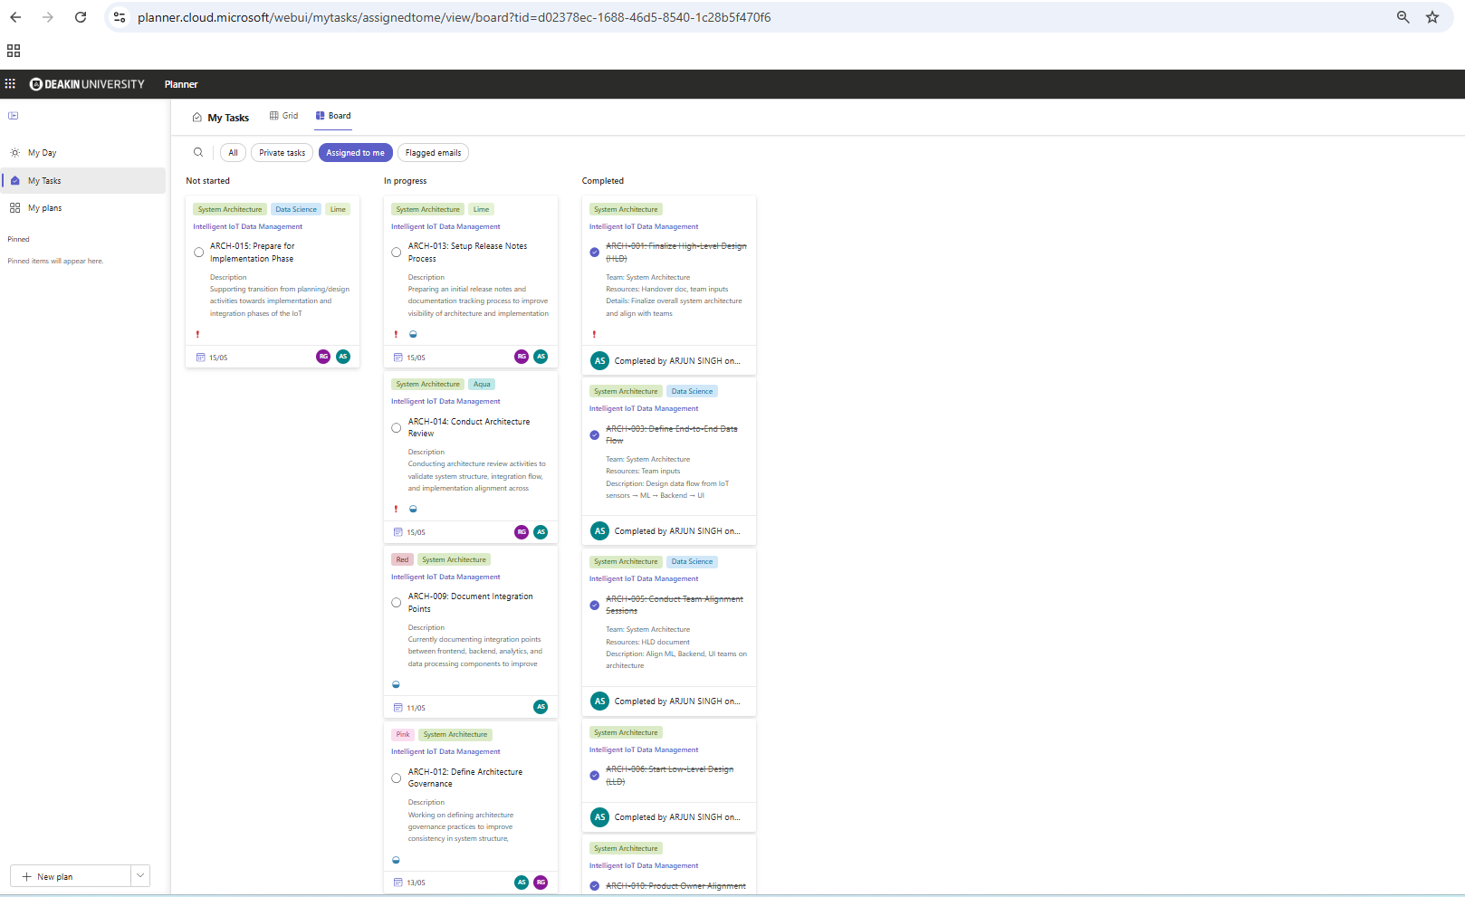

Certificate copy of the Course


Project Worklog
PROJECT_HOURS_LOG_WEEK1_8.docx

Research References Used
- https://www.linkedin.com/learning/software-architecture-foundations/the-importance-of-software-architecture?u=2104084
- https://lms.simplilearn.com/courses/8356/Introduction-to-Software-Architecture.
- Deakin AI and Literature Review Guide
https://deakin.libguides.com/ai-literature-review

